Renju lesson on June 7, 2001

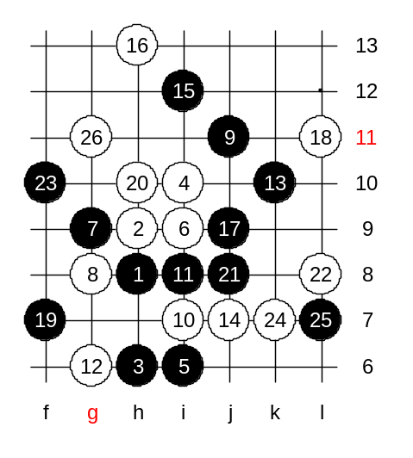
Hello all! Welcome to Online Renju Class. Today we will continue with another 16th move. It leads to the most popular variant of d11 opening in past few years. How many of you know the best 17th move here? I agree h7 is the best. But before that, lets try some other 17th moves. The move 20-h10 was first played by me long ago. It is a good balancing move and active too. White has 3x3 at k7 now. Right? So black must block it. I have a question, can black put g11 now? No, black loses by 3x3. So, black must go j8. There are 21 moves on the board. This is the main path of this variant of the 17th move. Here I used another style than Nakamura. I played 22-L8, but Nakamura prefers 22-k8. Black continues development on the left side with f10, blocking white structures at the same time. In the first game in the history of this variant, exactly all these moves were played, too. I think g11 is an useful point for white, however it may be good to prepare the k7 point first. That way white will have a defensive four to g7 in case black wants to attack on the left side later. Now we are free to go g11. The outcome of this variant is about equal.

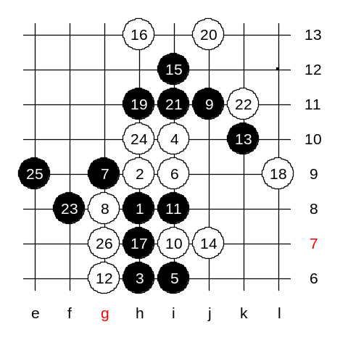
Lets check the main 17th move now. There black practically gets the winning advantage everywhere. This was the “hot” variant 2 years ago. I am not sure who found this 17th move first. It may have been one of the Swedish players. At first, everyone laughed at this move 3 years ago. Me too. I thought, this move h7 cannot be a serious move. But later, after serious analysis I realized its value. Can anyone of you tell me any reason why h7 is better than j9? You don’t see the real reason. Hmmm.
The reason is that when we played a move to j9 earlier then white got a good defense to L11, and at the same time the lower white line was still open. Now, in case of 17-h7, even if white goes L11, it is weak because the white’s lower line is already closed. White has a chance to defend if white has L11 stone and open line below. But if white doesn’t have either L11 or lower line, then black practically wins everywhere. Now, white has three main blocks here. Please name the spots. Yes, j9, L9, L11. We try L9 first. Black takes the h11 point – it is the key point in most of variants of this 17th move. The idea of h11 is simple – to be active and also control white’s counter-attack. Now that the diagonal i10_L7 is closed, the white’s attack is dead. Move 20-j13 was weak and black wins. Since it looks so easy, it will be your medium level homework. Please find the black win.
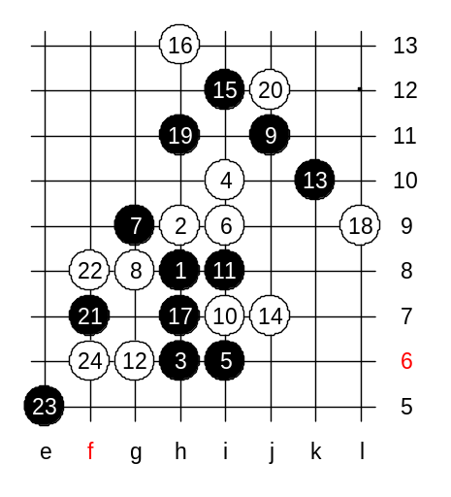
Another 20th move, 20-j12. Move 21-f7 is a positional style. Black develops slowly. Those who have downloaded the space and connections article, they already know it.
This will be the advanced level homework. Please find the black win. Several development moves may be needed here.

